The Department of Environmental Sciences and Engineering Hosts:

**ZOOM LINK**[Click Here](https://unc.zoom.us/j/92180679405)

**“Intro to Environmental Consulting: Case Studies, Creative Solutions, and Your Career”**

**Tuesday, October 22, 2023 | 10:00 A.M. ET  
Michael Hooker Research Center – Room 2005**

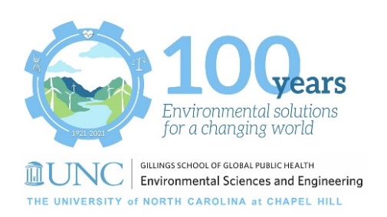 **Robert W. Plybon, PE** Environmental Engineer & Project Manager  
 EKI Environment & Water, Inc.

**About the presenter:**

Mr. Plybon is a professional engineer and project manager with experience in site investigation, remediation, and mitigation for a variety of environmental contaminants including PFAS, VOCs, petroleum hydrocarbons, pesticides, PCBs, metals, PAHs, tritium, and radon. His experience includes site investigation, design, operation, and monitoring of vapor intrusion mitigation and dual-phase extraction systems, design of landfill containment systems, preparation of construction plans and specifications, construction management, hazardous waste characterization and disposal, and risk assessments. He has experience providing high-level programmatic support for his clients including the facilitation of meetings and consensus with and preparing complex reporting for environmental regulatory agencies like the New York State Department of Environmental Conservation, the California Department of Toxic Substances Control, and the United States Environmental Protection Agency. Mr. Plybon holds Professional Engineering licenses in CA, NY, NJ, MA, CT, and NC.